**End to End Portal for Covid-19**

**By**

**Het Shah 17bit103**

**Saiyam Shah 17bit104**



**DEPARTMENT OF COMPUTER SCIENCE & ENGINEERING**

**Ahmedabad 382481**

**Ahmedabad 382481**

**CERTIFICATE**

This is to certify that the Minor Project entitled “End to End Portal for Covid” submitted by Het Shah(17bit104), Saiyam Shah(17bit104), towards the partial fulfillment of the requirements for the degree of Bachelor of Technology inInformation Technology/Computer Engineering of Nirma University is the record of work carried out by him/her under my supervision and guidance. In my opinion, the submitted work has reached a level required for being accepted for examination.

Prof Dhaval Jha Dr. Madhuri Bhavsar (HOD)

Assistant Professor Dept. of Computer Science & Engineering,

Department of Computer Science & Engg., Institute of Technology,

Institute of Technology, Nirma University,

Nirma University, Ahmedabad

Ahmedabad

**ACKNOWLEDGEMENT**

We would like to express our deepest appreciation to all those who provided us the possibility to complete this report. We acknowledge with thanks, the support rendered by Prof. Dhaval Jha, under whose guidance we were able to complete the task in a given period of time. This report could not be completed without the coordination of the team members Het Shah and Saiyam Shah.

**ABSTRACT/ OUTLINE**

The aim of our project was to provide a one stop portal for everyone for information regarding the covid-19 pandemic. The modules that we have included are question answering bot that can answer any question regarding the pandemic, fake news detection that can answer whether the news snippet given was true or false and in the end a website that can serve all the information on the statistics of the pandemic.

**CONTENTS**

Certificate 1

Acknowledgment 2

Abstract 3

Table of Contents 4

**Chapter 1 Introduction 5**

1.1 General 5

1.2 Literature Reviews 5

1.3 Scope of Work 5

**Chapter 2 Live Tracking 6**

2.1 Objective 6

2.2 Software Requirement 7

2.3 Methodology 7

2.4 Live Tracking Prototype 7

**Chapter 3 Chatbot System 10**

3.1 Objective 10

3.2 Software requirement 10

3.3 Using NLP 13

3.4 Using ANN

**Chapter 4 Fake News Detector 16**

4.1 Objective 16

4.2 Software requirement 16

4.3 Working 17

**Chapter 5 InfoChart COVID-19 18**

5.1 Objective 18

5.2 Working 18

**Chapter 6 Appendix – A List of Useful Websites 20**

**Chapter 7 References 20**

**Chapter 1 Introduction**

1.1 General

The COVID-19 pandemic which started in 2019 has rapidly spread across the globe and has infected millions of people and taken the lives of hundreds of thousands. Over the years, the role of Artificial intelligence (AI) has been on the rise as its algorithms are getting more and more accurate and it is thought that its role in strengthening the existing healthcare system will be the most profound. Today’s world is more about getting more efficiency and not about the cost in achieving it, and technology has made it possible by providing us the system Tracking, Detection, Artificial Bot which makes human life free and more comfortable.

1.2 Literature Reviewed

For the creation of our End to End Portal for Covid , we used the reference of various research papers in esteemed journals such as Springer, ACM, IEEE, etc. We also used the youtube platform to get some inspiration about different modules and technologies which can be used to accomplish it.

1.3 Scope of Work

In the system that we have created, it is being modified to suit every possible scenario. No matter what question the user will ask the chatbot will try to answer with maximum accuracy and the news that we have considered will also be updated from time to time to increase the corpus size and increase the efficiency. The website containing the statistics will include every country and we have developed several types of graphs to visualize the growth.

**Chapter 2 Live Tracking**

2.1 Objective

The main objective of End to end Portal for Covid-19 is to minimize human intervention as much as possible with the help of today’s technology. In today’s where it is so difficult to track down any person’s location this application will help the User to send its latitude and longitude to hospital staff in case of any emergency. Receiving the scales from the client Automatically location will be located in the map and staff members can reach out there easily.

2.2 Software Used

The Software used is shown as below.

* Node Js
* Beebotte Application

3.3 Methodology

**Beobotte Application**

Beebotte is an application that connects key key components to power the apps linked to the Internet of Things and real-time. A rich and easy-to-use API enables you to speed up your linked application's development and decrease your overall processing efficiency.

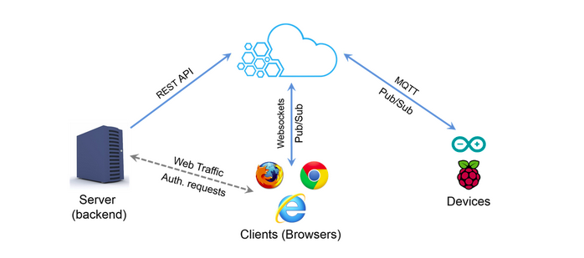

Beebotte Application is a channel-based Publish/Subscribe model that provides bidirectional information transmission between your users connected or machines. It allows both at the same time to read as well as write the data and to publish by backend applications.

**Working Model**

In this project, Beebotte application is being used to Demonstrates how to develop a basic web application for geolocation tracking

For this we have created two files :

1. **track.html** : this file uses GeoLocation API that monitor a system Position and publish it to Beebotte
2. **monitor.html** : It reacts to the location published by track.html and locates it to Google maps

**Working**

1. **Open the terminal and run a command ‘***npm install***’ .**

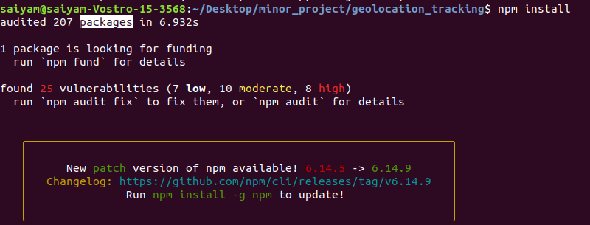

1. **Type ‘node app.js’ in terminal**



1. **Open the localhost:8080/track.html**

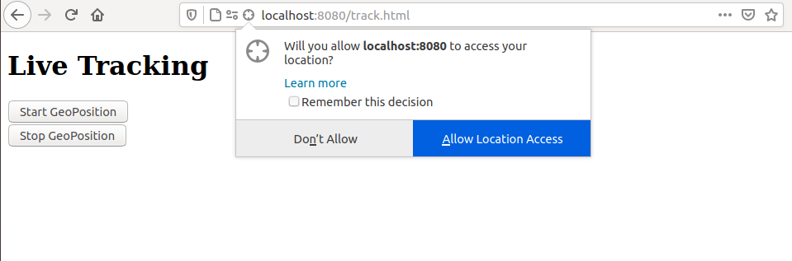

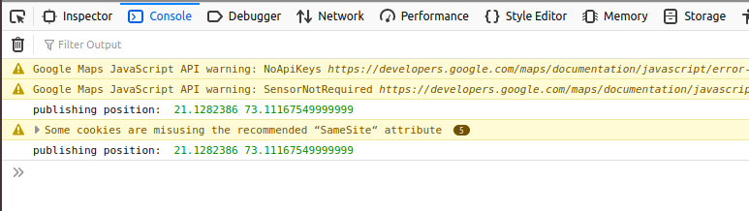

In the console it publishes the latitude and longitude to beebotte application.

1. **Open the localhost:8080/monitor.html**

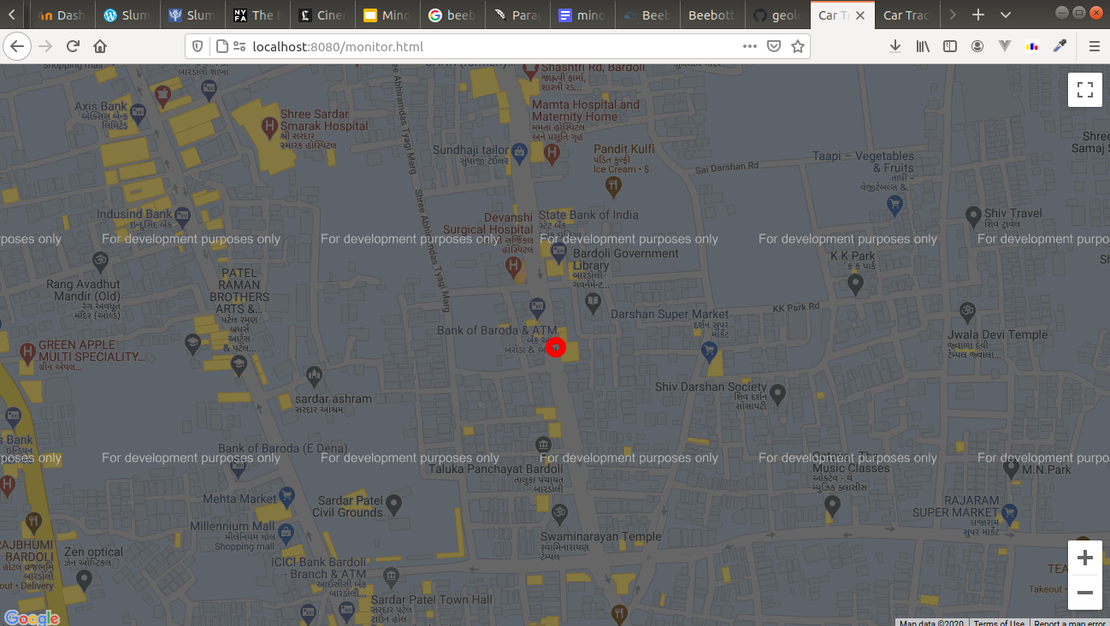

The location which is published by track.html is subscribed by monitor.html which is shown in google maps.

‘red’ dot indicates the location.

**Chapter 3 Chatbot**

3.1 Objective

The main objective of the chatbot is to answer all the query that the user post.

3.2 Software/HardWare Requirements

1. Python
2. Tkinter
3. Dataset
4. flask

3.3 Using NLP

Scraping.py uses webscraping from over a 100 websites and stores the information in the file info.txt

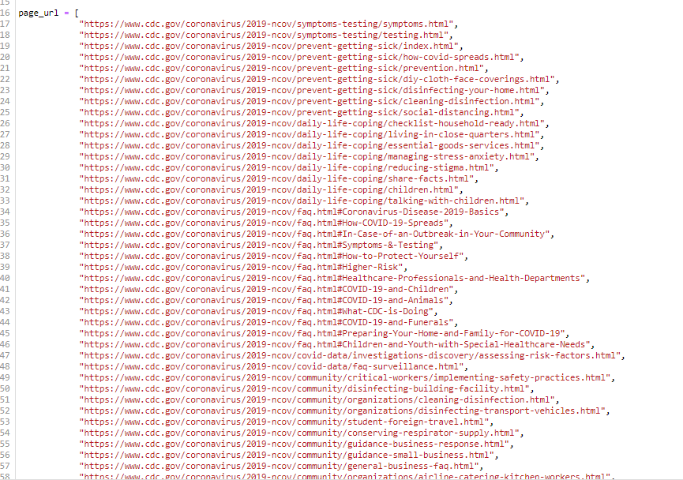

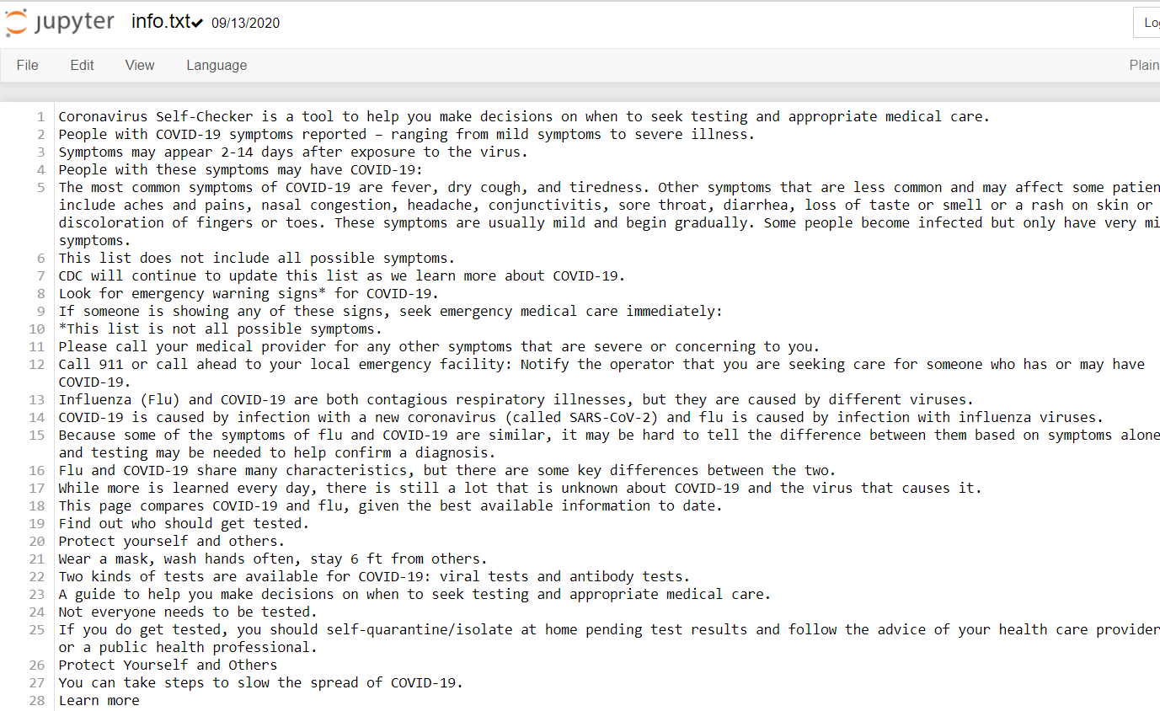

The data that is scraped from the websites and is stored in the file info.txt

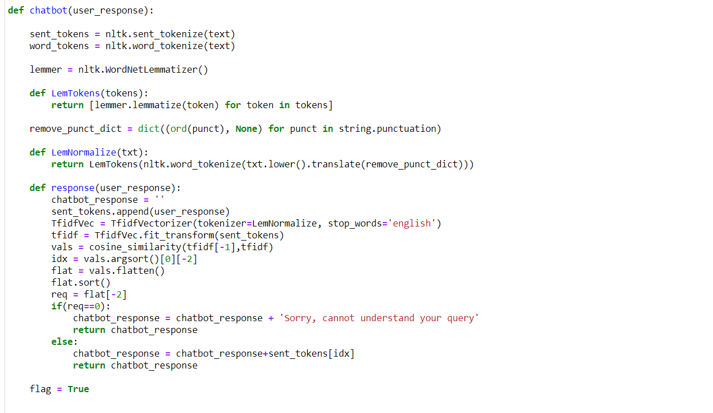

In the processing part, we used stop word removal, stemming, etc and then converted it to the tf-idf form. When the user sends a request we use cosine similarity and reply with the most relevant information

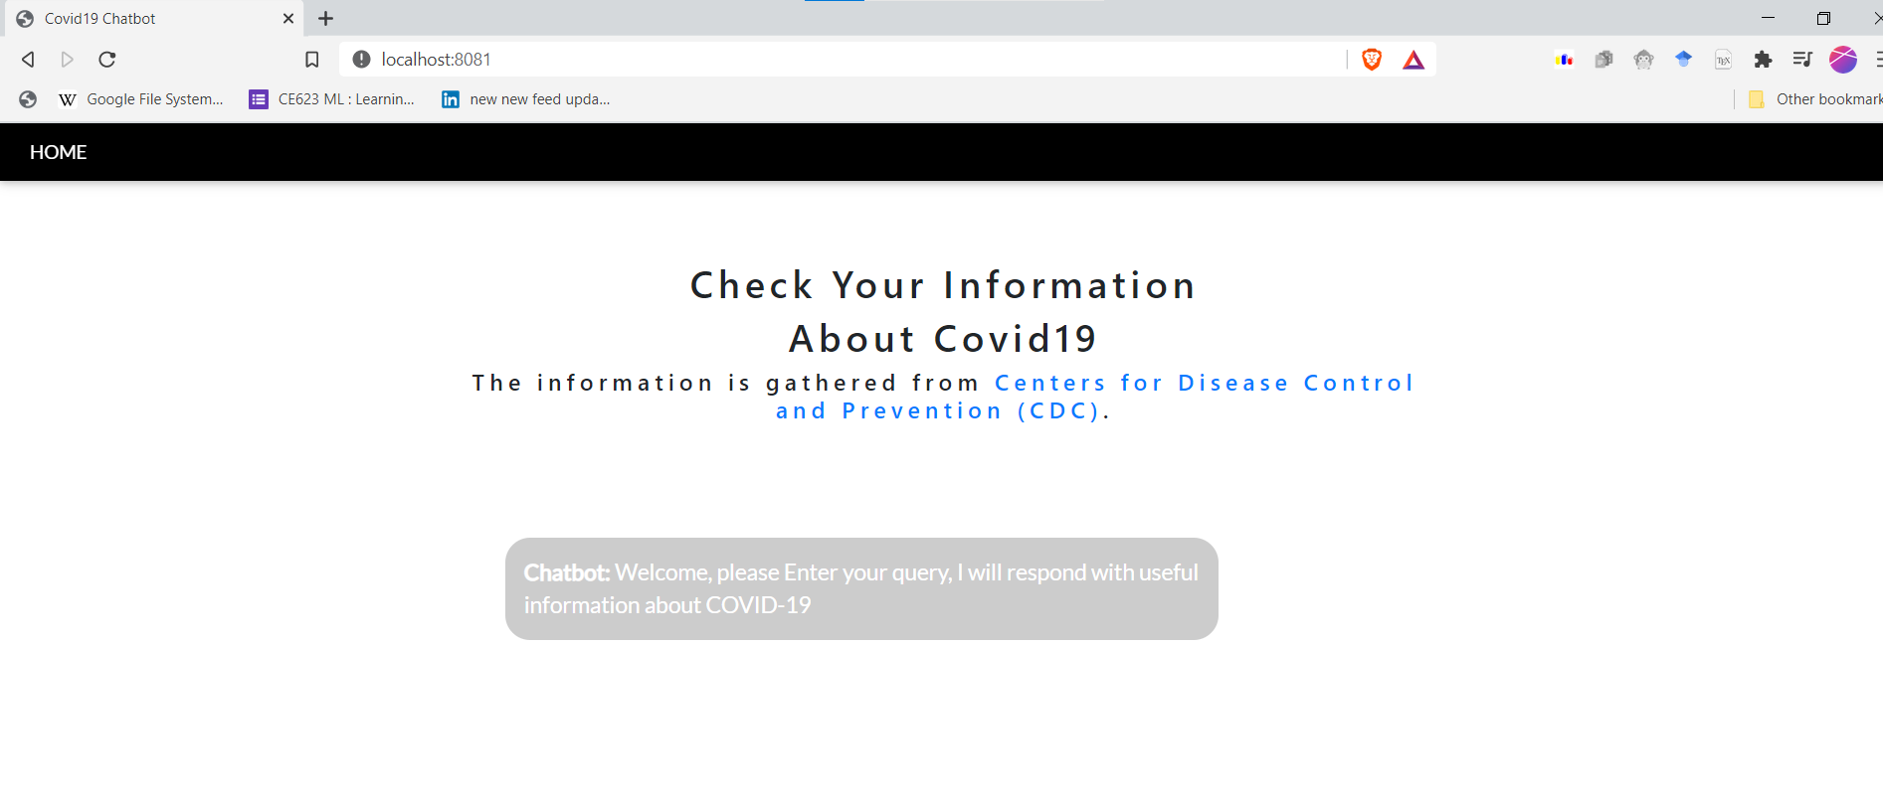

Home window

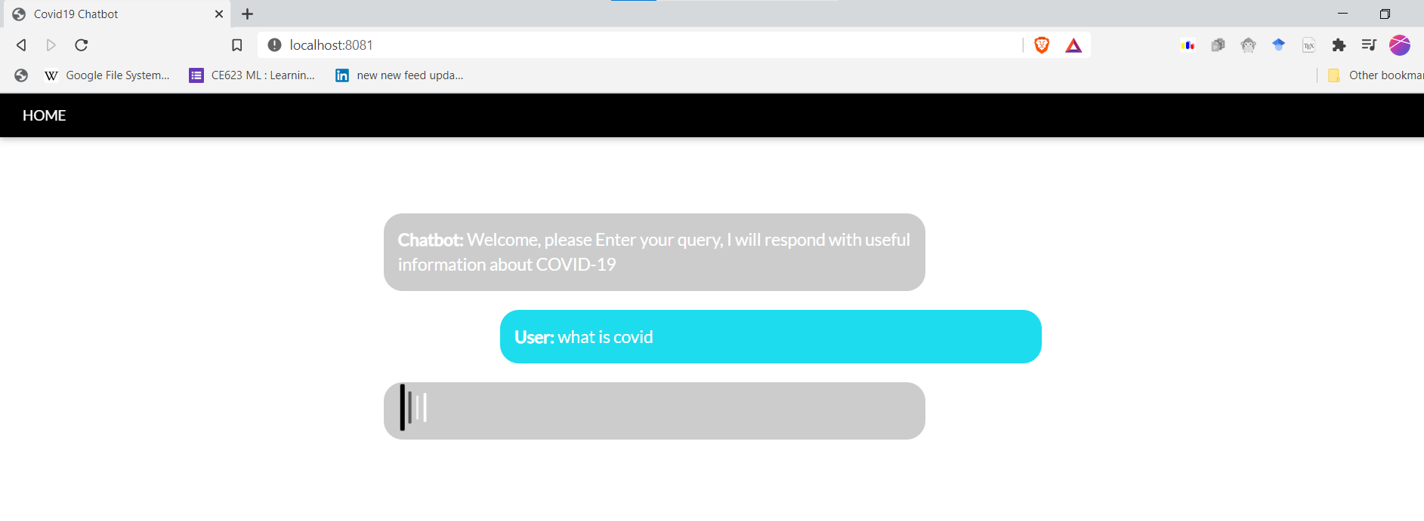

searching for answer

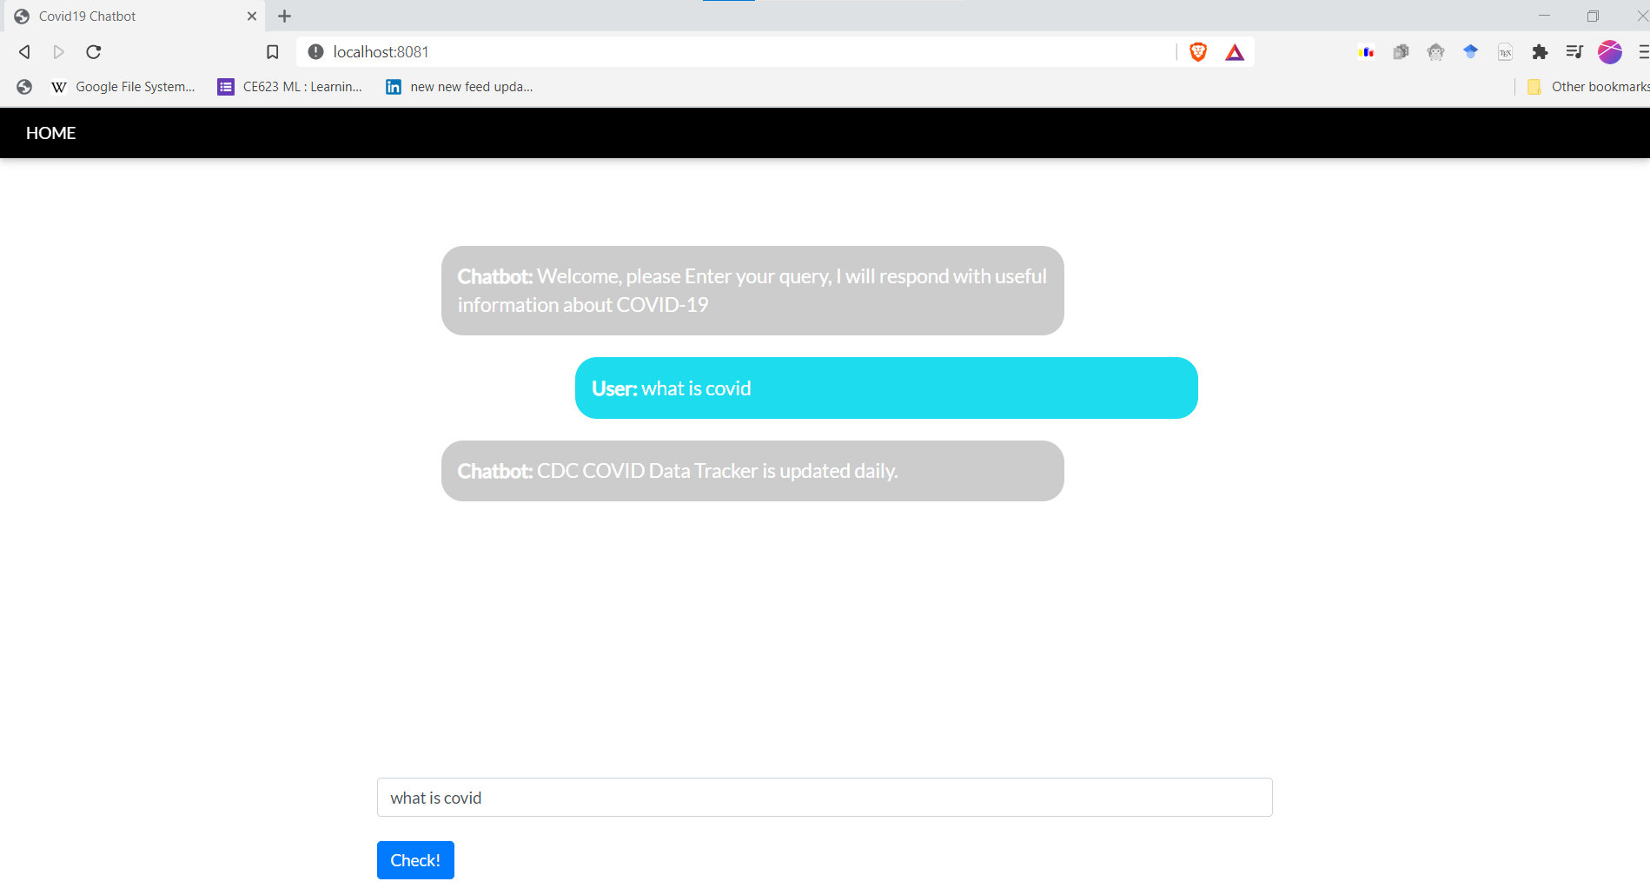

received the answer, but not the answer that we were looking for

4.3 Using ANN

Since using the TF-IDF we were not able to get the required answer and often we got wrong answers, we used ANN to increase the efficiency.

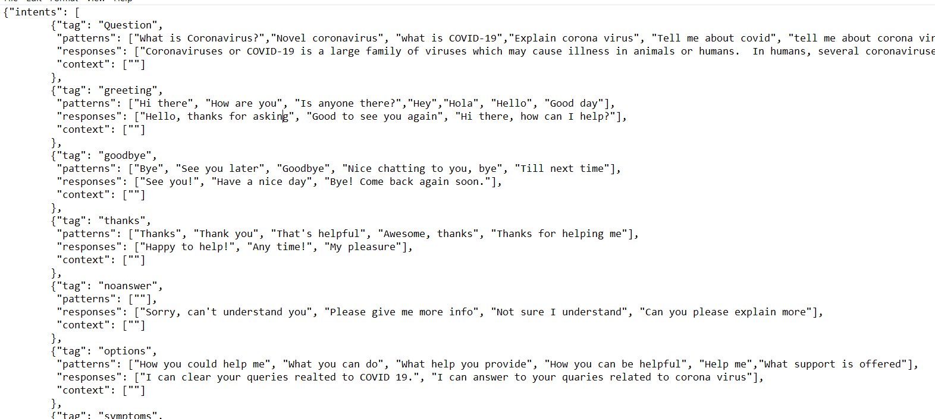

The dataset consisted of tags and the key words and a group of responses. If the tag of the question was identified, any one response from the array of responses will be presented. There were only 64 tags

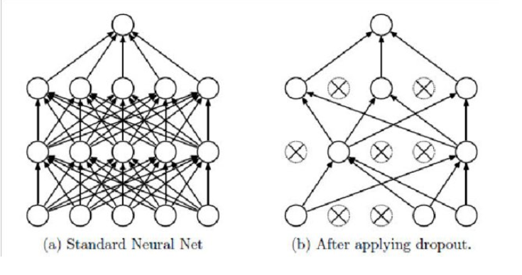

As our dataset size was small, we had to use dropout to increase the accuracy of the network

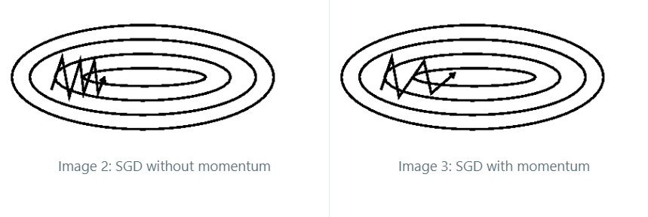

To reach the minima faster we used SGD with momentum and in turn we used the Nesterov optimizer that can look ahead.

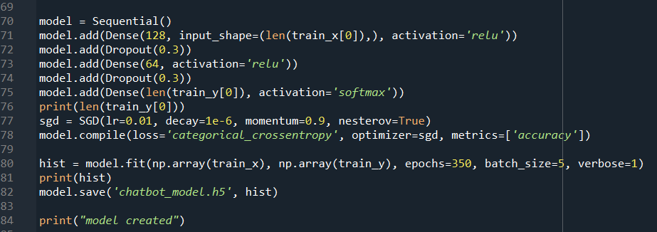

The ANN we had had 3 layers. The first layer had 128 neurons with relu activation function. The second layer had 64 neurons with the relu activation function. The last layer had 63 neurons as thats the number of tags that we had in the dataset.

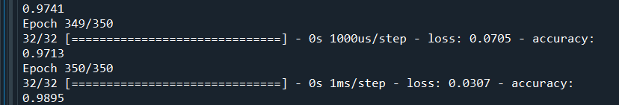

We got accuracy of **98.95 percent** after 350 epochs

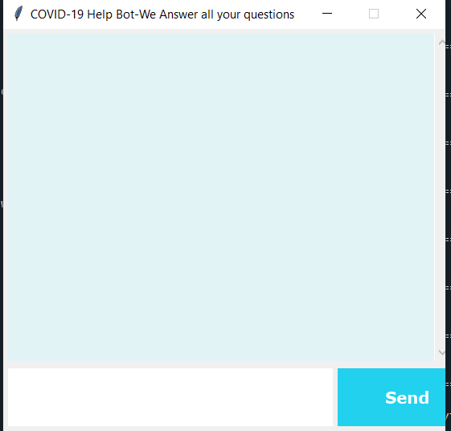

The charbot gui that we created using the python tkinter

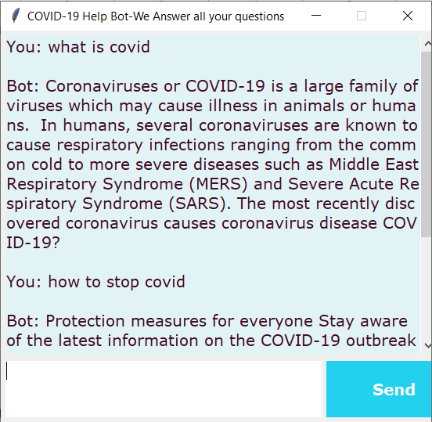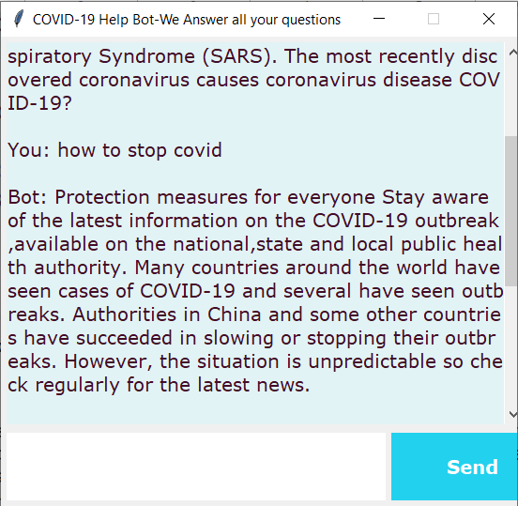

The chatbox working and answering the questions

**Chapter 4 Fake news Detection**

**4.1 Objective**

The rate at which the Fake News has spread today has facilitated work to reduce the harm and public instability caused by their dissemination in different places,which makes it necessary to create fake news detector.

The main objective of the Fake news Detector is to help consumers uncover variations of misleading news. In order to access misleading social media content, we could use different models.

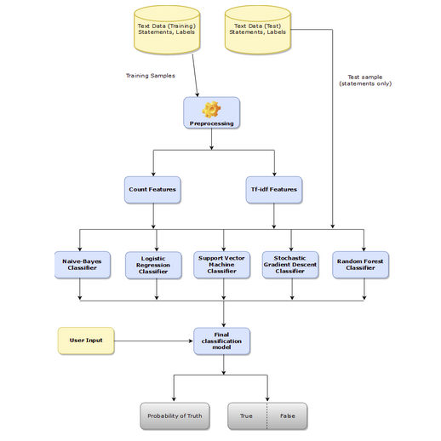

Fig : Architecture of Fake News Detection Algorithm

4.2 Software Requirements

The Software used is shown as below.

* Python 3
* Jupyter Notebook

4.3 DataSet

The DataSet which was used was manually created which contains 74 rows and 6 columns.

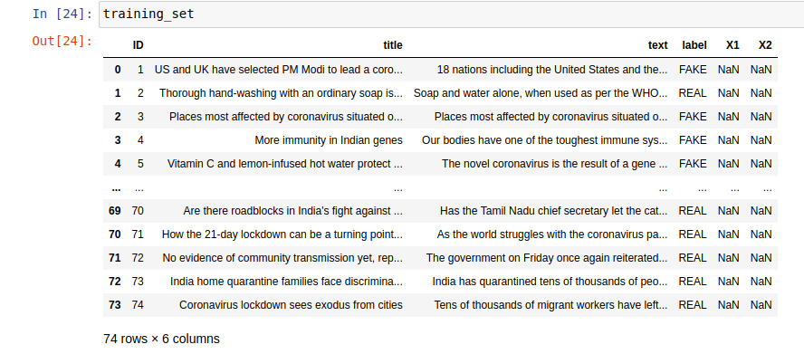

**4.3 Working**

1) Distribution of data

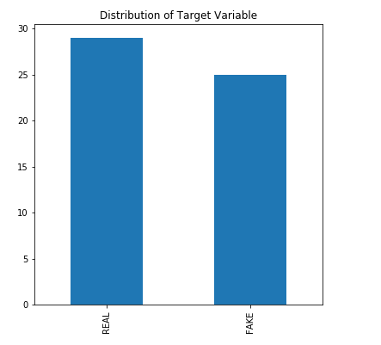

2) Wordcloud which contains the most frequently word.

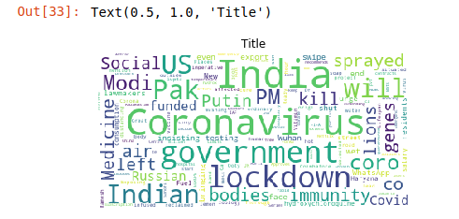

3)Testing Dataset

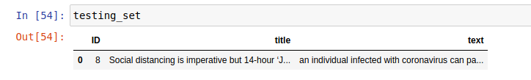

4) Output of Testing DataSet.

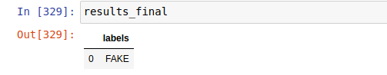

**Chapter 5 Infochart COVID-19**

**5.1 Objective**

In this module we use an API to fetch data and then we visualize it using react JS in forms of many charts such as line chat, bar chart, radar chart, pie chart and polar chart. The information is update periodically by the API

**5.2 Working**

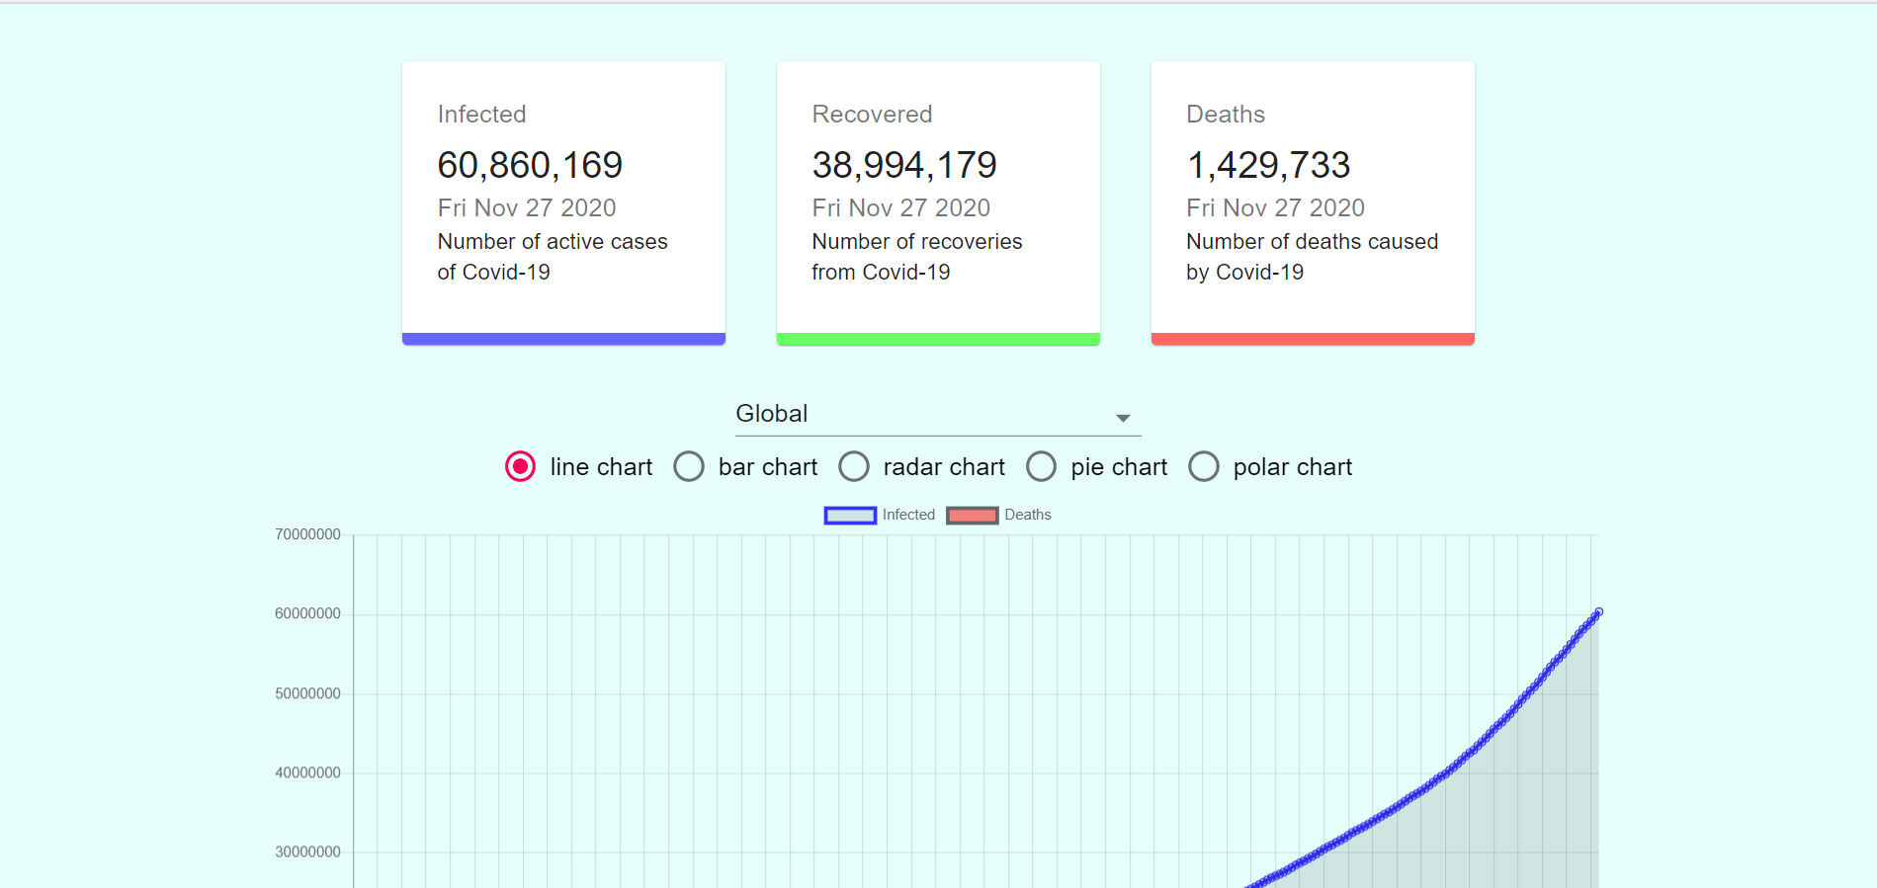

The top 3 boxes show the total number of cases in the region that we have selected, the number of recovered cases and the number of deaths due to covid in the country

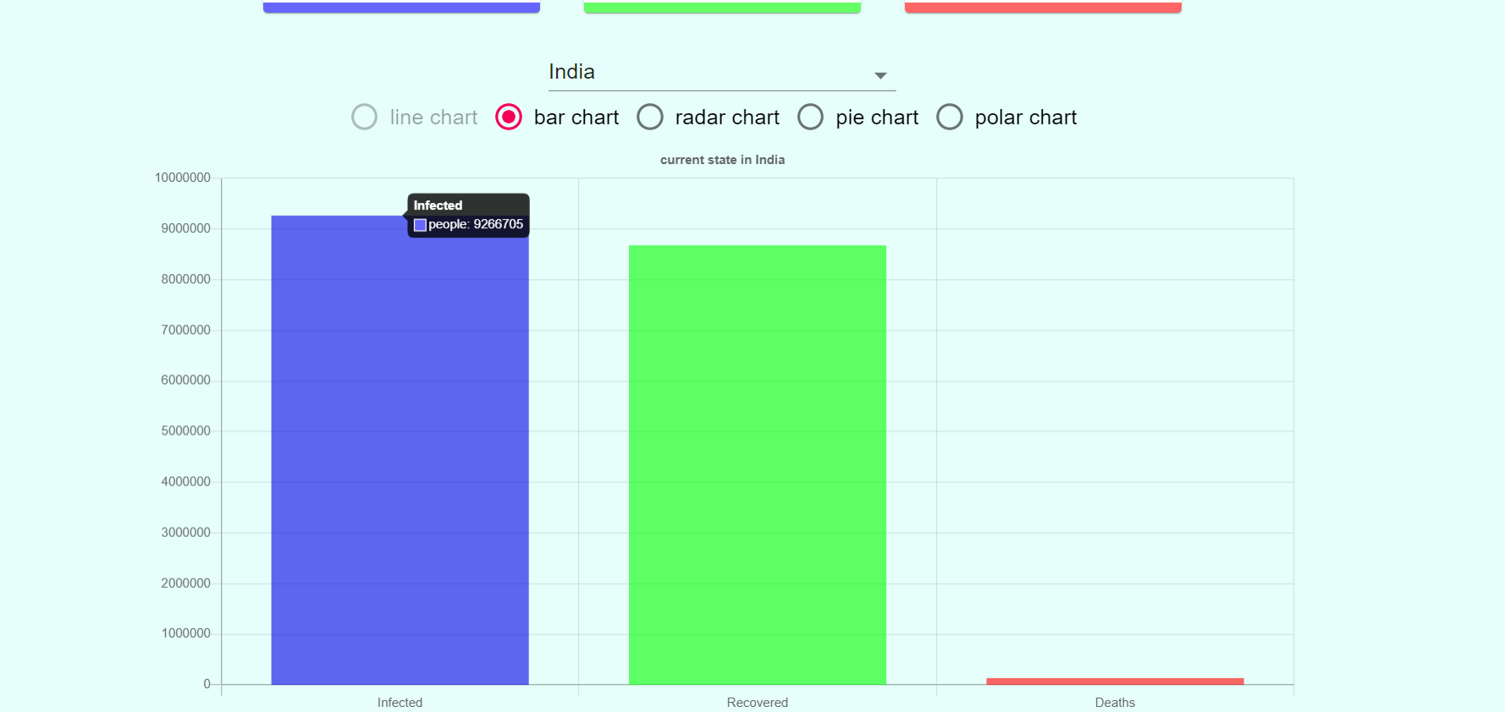

bar chart for India

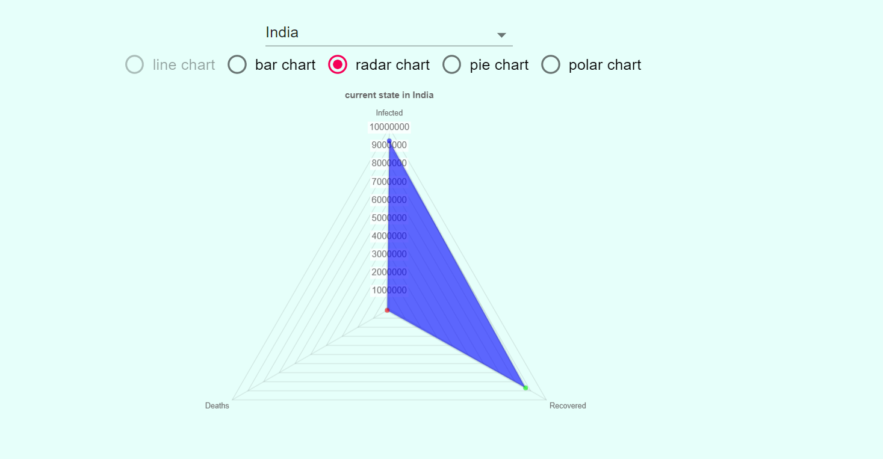

Radar Chart for India

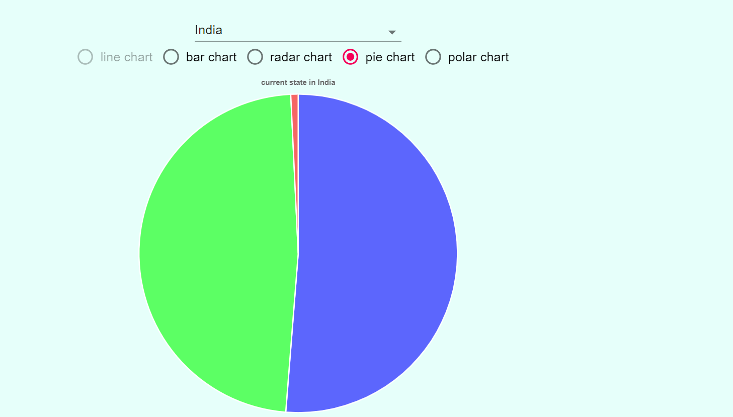

Pie chart for india

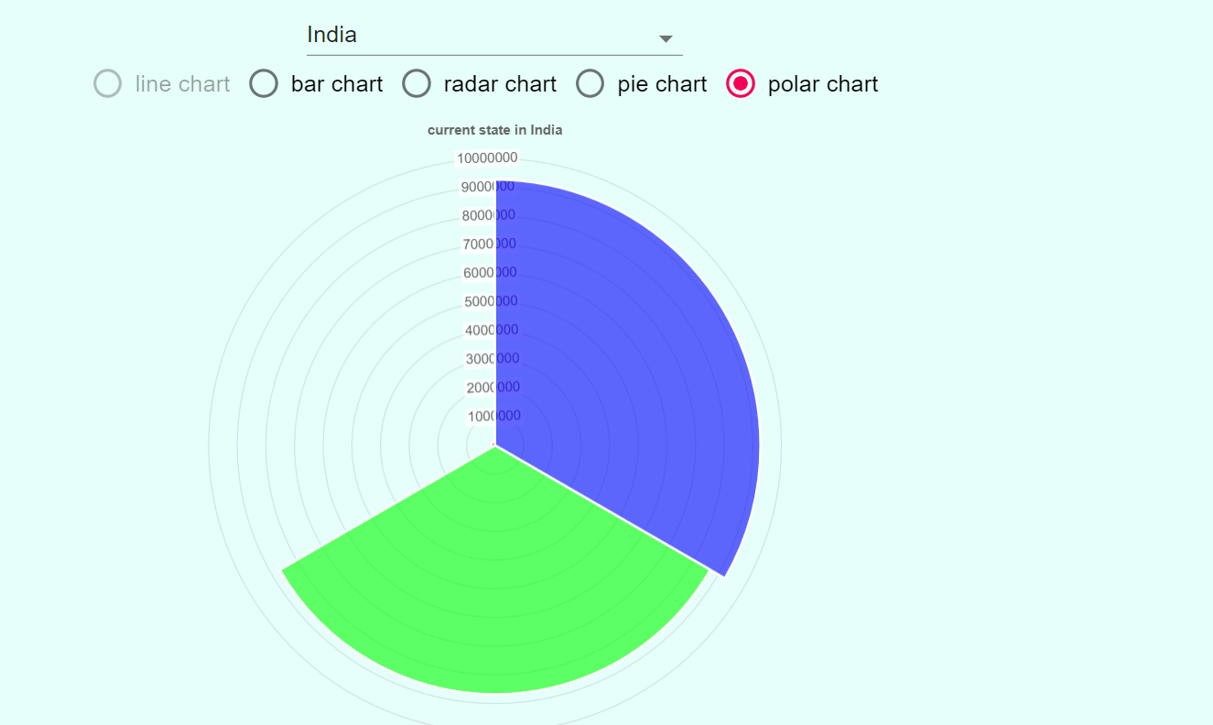

Polar Chart for India

**Appendix – A List of Useful Websites**

1. <https://docs.python.org/3/library/tkinter.html>
2. <https://dev.mysql.com/doc/connector-python/en/>
3. <https://realpython.com/python-send-email/>
4. <https://stackoverflow.com/questions/27327513/create-pdf-from-a-list-of-images>
5. <https://docs.opencv.org/2.4/doc/tutorials/tutorials.html>

**References**

1. Dong, E., Du, H. and Gardner, L., 2020. An interactive web-based dashboard to track COVID-19 in real time. *The Lancet infectious diseases*, *20*(5), pp.533-534.
2. Boulos, M.N.K. and Geraghty, E.M., 2020. Geographical tracking and mapping of coronavirus disease COVID-19/severe acute respiratory syndrome coronavirus 2 (SARS-CoV-2) epidemic and associated events around the world: how 21st century GIS technologies are supporting the global fight against outbreaks and epidemics.
3. VolppKevin, G., 2020. Asked and answered: Building a chatbot to address covid-19-related concerns. *NEJM Catalyst Innovations in Care Delivery*.
4. Li, Y., Grandison, T., Silveyra, P., Douraghy, A., Guan, X., Kieselbach, T., Li, C. and Zhang, H., 2020. Jennifer for COVID-19: An NLP-Powered Chatbot Built for the People and by the People to Combat Misinformation.